# EduStream Online Learning Platform

Name: Prerna Kumari

Branch: B.Tech Computer Science and Engineering (CSE)

Class: 7th Semester

Project Title: EduStream – A Modern Online Learning Platform

## 1. Introduction

EduStream is an interactive web-based learning platform designed to enhance online education through multimedia-rich courses and seamless user experiences. The goal of this project is to create a scalable and secure e-learning system that allows users to browse content, manage preferences, track progress, and make secure purchases. The platform integrates React.js for the frontend, Laravel with MongoDB for backend services, and Tailwind CSS for responsive design, ensuring both visual appeal and performance efficiency.

## 2. Features Implemented

### 2.1 Media Gallery & Playback Controls

Description: Allows users to explore video lectures, audio clips, and visual materials for each course.  
Implementation:  
• Developed a responsive media gallery using React components and Tailwind CSS.  
• Integrated HTML5 <video> and <audio> elements for interactive playback.  
• Added Canvas API overlays for visual effects like progress visualization and watermarking.  
• Used event listeners for playback control (play, pause, seek).  
User Benefit: Provides an immersive learning experience with intuitive media navigation.

### 2.2 User Preferences & Dark Mode

Description: Users can toggle between light and dark themes, and their preferences remain consistent across sessions.  
Implementation:  
• Tailwind’s dark mode utility classes used for theming.  
• React state and localStorage ensure persistence of user preferences.  
• Theme automatically loads based on previous choice at app initialization.  
User Benefit: Personalized and accessible interface for all users.

### 2.3 Authentication & Secure Purchases

Description: Secure login and registration system for managing personal accounts and course purchases.  
Implementation:  
• Implemented JWT-based authentication in React and Laravel.  
• Shopping cart built as a reusable React component with MongoDB integration for order persistence.  
• Data encryption and API validation applied for secure communication.  
User Benefit: Safe, smooth, and reliable course enrollment and payment experience.

### 2.4 Real-Time Validation

Description: Provides instant feedback during sign-ups and quiz interactions.  
Implementation:  
• Used HTML5 Constraint Validation API with JavaScript for form validation.  
• Dynamic error messages display immediately for invalid inputs.  
User Benefit: Reduces form submission errors and enhances user experience.

### 2.5 Dashboard & Analytics

Description: Displays progress reports, activity logs, and analytics visualizations.  
Implementation:  
• Created dashboard using Tailwind UI and Headless UI components.  
• Integrated Chart.js for displaying performance analytics.  
• Aggregated user data fetched via REST API from Laravel backend.  
User Benefit: Enables learners to track progress and stay motivated.

## 3. Architecture & Technology Choices

Frontend: React.js, Tailwind CSS, Headless UI  
Backend: Laravel Framework with MongoDB  
State Management: React Context API and LocalStorage  
API Communication: RESTful API with JWT-based authentication  
Design Principles: Responsive design, modular architecture, and reusable components  
Security: Encrypted tokens, input validation, and secured API routes

## 4. Implementation Challenges & Solutions

|  |  |
| --- | --- |
| Challenge | Solution |
| Synchronizing frontend and backend states | Used React Context and Axios interceptors for consistent JWT handling. |
| Ensuring authentication security | Applied hashed passwords, token expiry, and middleware-based access control. |
| Managing media-heavy performance | Implemented lazy loading and caching for large video files. |
| Real-time form validation | Integrated JavaScript event-based feedback for inputs. |
| Handling background tasks (e.g., email confirmation) | Utilized Laravel job queues for asynchronous processing. |

## 5. Future Scope

• Add AI-based personalized course recommendations.  
• Integrate payment gateways like Stripe or Razorpay.  
• Expand dashboard analytics using D3.js for better visualization.  
• Develop a mobile-friendly Progressive Web App (PWA).  
• Enable real-time chat or discussion forums for learners.

## 6. Conclusion

This EduStream project demonstrates the successful implementation of a secure, responsive, and user-friendly e-learning system. It integrates modern web technologies such as React, Laravel, and MongoDB to ensure scalability and reliability. The project lays a strong foundation for future expansion into a fully-fledged educational platform capable of handling large-scale users and interactive learning environments.

## 7. Instructions to Run Prototype

1. Clone or download the project repository.  
2. Install dependencies using npm install and composer install.  
3. Start backend server using php artisan serve.  
4. Run frontend using npm run dev.  
5. Access the application at <http://localhost:3000>.

## 8. Prototype

Dark Mode:

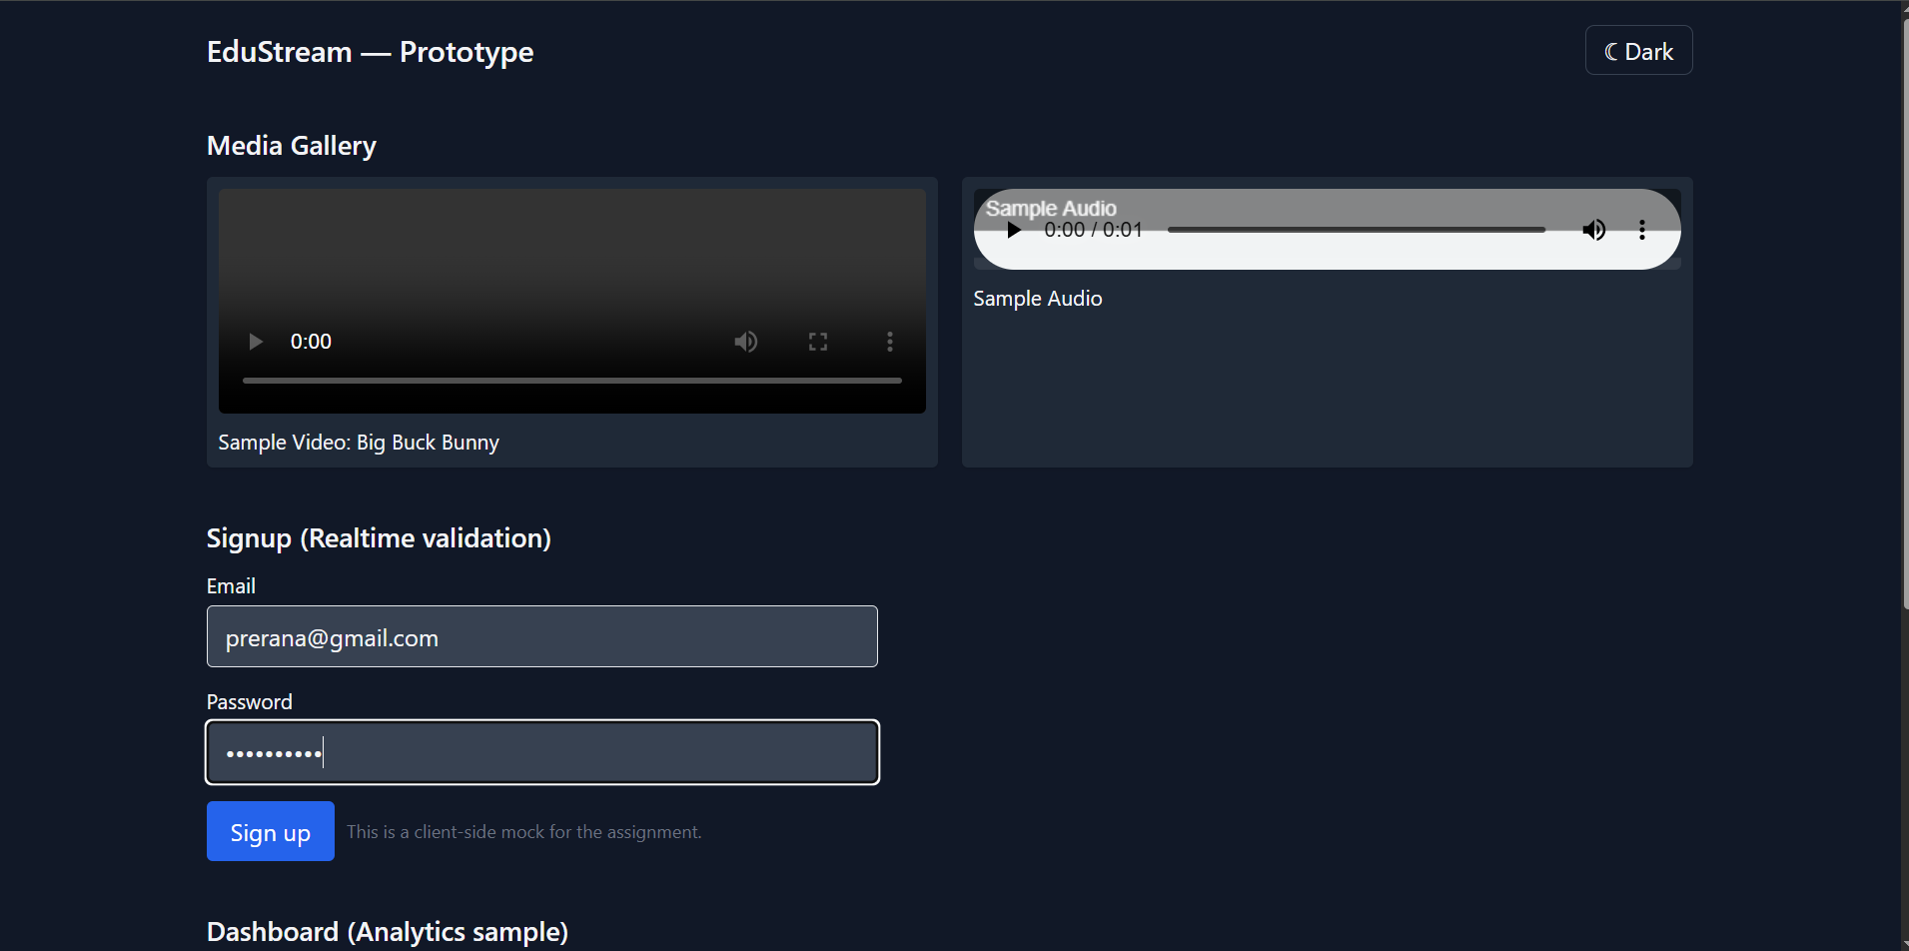

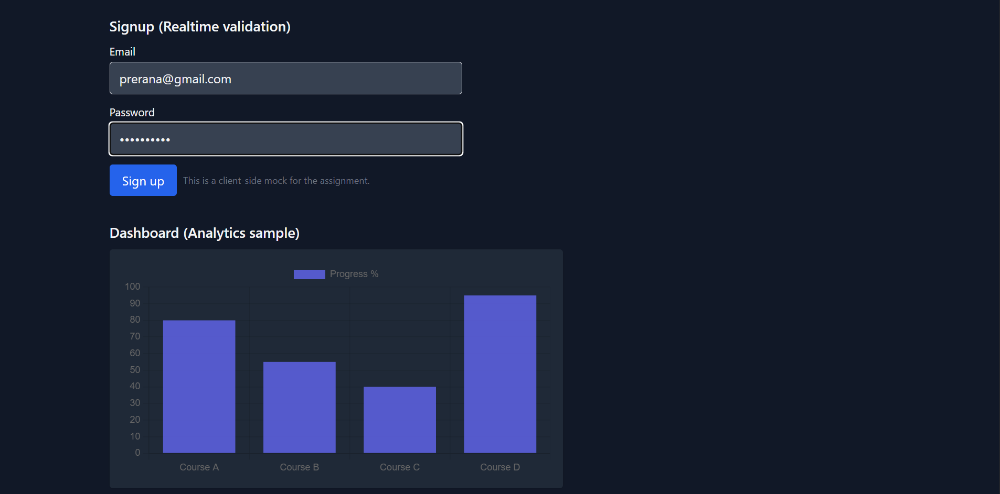

Light Mode:

